INVENTORY WITH NEW WORTH DATA LT5101H TRICODERS
- Plug tricoder USB cord into computer and then plug cord into Tricoder. You will need to install the driver, which should run automatically. Unplug from tricoder after this is done.
- Turn tricoder on (small green button, top left)
- Hit number 1 (one) key for “DATA COLLECTION”
- Hit number 0 (zero) key for “DEFAULT PROGRAM”
- Scan barcodes.
- When done scanning barcodes and you are ready to upload, attach USB cord to bottom of scanner (directly under the . (period) key (lift rubber stopper to plug in cord).
- Open Inventory.
- Click “CREATE NEW SESSION”
- Go to ACTION and choose INVENTORY OPTIONS. 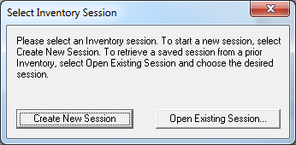
- Add “New Pattern” if you need. Also make sure your Institution Name and Database Set are correct and hit SAVE.
- Go to FILE and choose UPLOAD FROM READER.
- Attach tricoder to USB cord that is plugged into your computer.
- Hit F1 on the tricoder.
- Hit number 2 (two) on tricoder to DATA UPLOAD.
- Notification will appear on the tricoder that says:
“In USB Host Control Mode. Press F2 to Upload by USB HID Keyboard mode, or other key to exit” Hit the F2 key
- Barcodes will then upload to the computer.
- Make sure they are all uploaded in the screen: 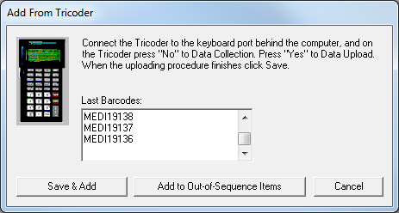
- Click SAVE & ADD and name the file anything you want. You should save this file somewhere on your own personal drive, if possible, so that you don’t lose the data.
- In the inventory module, you can then click the + key next to the data you just saved to see the barcodes you just scanned. 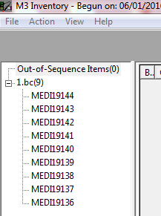
- Then on the tricoder it will say “END OF TRANSMIT. DEL FILE [YES/NO] and you should hit big green button ENTER/YES. It will ask you if you are sure, and you click yes button again.
- Then you can choose number 1 (one) again to do more data collection and scan more books!
- When you are completely done with inventory scanning/uploading, please remember to TURN the tricoder OFF. These run on lithium batteries only, no AA batteries. Also remember to pack the USB cord back into the box with the tricoder prior to sending the tricoders back to me.
- When you are completely done with scanning and uploading, go to ACTION and DO INVENTORY. Then you can print your reports.
REPORTS:
- Newly Found: these are books that were missing in the past and are actually on the shelves now. You can mark them all as PRESENT by going to ACTION and choosing MARK NEWLY FOUND. This is all you have to do with this report.
- Missing: Obviously you know what this report contains. You can go through to see if sections of your library were missed, and rescan/rerun the inventory process if you have a lot of missing. Also, you can go to ACTION and choose MARK MISSING ITEMS if you want. This will add the 994#a field to the holding record of each book and mark them as missing. If you then find the book, change the 994#a to NORMAL or scan it in circulation in the STATUS column and it will automatically change the book to present instead of missing.
- Invalid Barcodes: These are barcodes that were scanned during inventory that are NOT in your catalog. Find these books and add them to Mandarin in cataloging.
- Loaned Shelved: these are books that are on your shelves but are still on loan to a student/teacher in circulation. Return these books in circulation.
- No Barcode: this report shows any bibliographic records in your catalog that have no holdings. If they are eBooks, cross them off the list. If they are actually records for books that you have no holdings for, delete them in your catalog. If they are actual books that you have in your library, add the holding records.
- Duplicate Barcode: this is a report that would show you if you have two holding records with the same barcode number in it. This rarely happens with M3 now. If you have duplicate barcodes, figure out which book actually has the number and change the other.
- Out of Range(s): is for partial inventories where you do a single range at a time (FIC only, etc.) and will show out of sequence books.
- Statistics: print this if you want. Shows how many books you scanned, etc.

